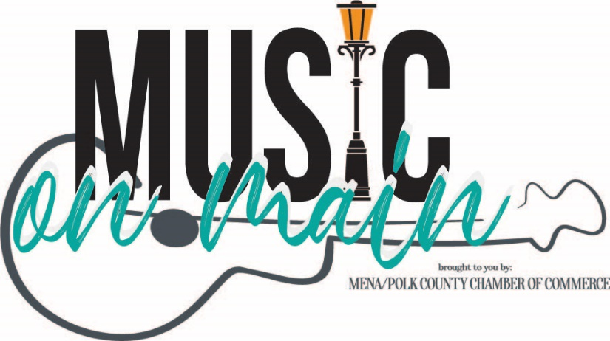
Music on Main
MENA, ARKANSAS
July 15, 2023
COMMERCIAL FOOD Vendor Application
Form Deadline: June 23, 2023
Acceptance Packets Mailed: June 30, 2023

Organization/Business Name:
Contact Person(s): Contact Phone:
Address:
City: State: Zip Code:
E-Mail:
Website: Social Media Accounts:
COMMERCIAL Food Vendors
Rates & fees are listed on the back of this form. The Mena Polk Chamber of Commerce Policy /Acceptance / Vendor Agreement will be mailed by June 30, 2023 and must be returned by July 15, 2023. Setup information, maps, etc. will be mailed to you as well. All commercial food vendors will be admitted at the discretion of the Mena Polk County Chamber of Commerce.
Photos of trailer and food items will be required with ALL application forms for ALL food vendors.
Please list ALL items you will be selling. Use and additional sheet if necessary.

Please provide the price range of your products (lowest to highest):

Trailer dimensions/size:
Spaces for commercial food vendors are tight, so please indicate total retail space required for your set-up. Please note Use of Vehicles & Trailers under Guidelines & Regulations in this application.
Please check if you require electricity? □ Yes □ No Voltage Total Amps
*Limited spacing available with electricity and water so send your application request in early. Electrical usage may be limited. Any and all electrical connections MUST be pre-approved and paid for in advance. Electrical connection must be made by an event representative. Only 1 A/C unit allowed per food vendor space.
*Water hoses are not provided. Water available only if requested and pre-approved.

Saturday, July 15, 2023, the event will be held from 6 pm to 9 pm on South Mena Street.
I, the exhibitor, agree to the terms on this form and acknowledge, if accepted as a vendor, I will receive the full written policy with additional terms, conditions, and regulations for the “2023 Music on Main” and my acceptance to the event will not be finalized until I have read, initialed, and signed the full written policy and vendor agreement. I agree to abide by all the terms set forth in this “Application Form” with no exceptions and do hereby contract space for the 2023 event.
Signature: Date:
Thank you for your interest in the July 15, 2023 Music on Main event.
Please return this form to:
Mena Polk County Chamber of Commerce | 524 Sherwood Avenue | Mena, AR 71953
Questions/Comments? Contact us at 479-394-2912 or director@menapolkchamber.com
Photographs of your food trailer and food items and proof of liability insurance
MUST be attached to this application.

2023 Music on Main
COMMERCIAL FOOD Vendor Rates & Fees:

10% of gross proceeds from the event, payable by cash or check.

Vendor agrees to keep complete records of all sales and receipts, and forward to the Mena Polk County Chamber of Commerce within 10 working days following the event, a detailed financial statement covering the event. Vendor further agrees to pay to the Mena Polk County Chamber of Commerce 10% of gross proceeds from the event, payable by check by July 21, 2023 .

*No canopies, tables, chairs, etc. are included. The fee is for the space only.
Set up time will be July 15, 2023, 4 pm

Guidelines & Regulations
Items restricted to sell: items include, but are not limited to, alcohol-related products and tobacco products. The previous list is for example purposes and is not all inclusive. The Mena/Polk County Chamber of Commerce has the sole and exclusive right to add additional items to the list before or during the event. The Chamber, in its absolute discretion, shall decide at any time, before or during the event, whether an item or product can be sold at a booth or on the premises. Should the Chamber exercise this right and inform a vendor that an item or product cannot be sold, the item will immediately be removed from the booth or exhibit area and the event premises.
Proof of Liability Insurance: A copy of your Proof of Liability Insurance MUST accompany your application naming the Mena Polk County Chamber of Commerce as additional insureds if you are participating as a commercial food vendor.
Fire, theft, damage: The Mena/Polk County Chamber of Commerce and Music on Main will not be responsible for loss due to fire, theft, winds, or other damage regardless of the cause. The Mena/Polk County Chamber of Commerce and Music on Main is expressly released from any loss, injury, or damage to persons or property.
Use of vehicles & trailers as booth space: Trailers will be allowed for COMMERCIAL food vendors. Photos of the trailer must accompany the application.
Failure to comply with regulations will result in the exhibitor being dismissed from the Music on Main event and any future Mena/Polk County Chamber of Commerce events.
Please acknowledge your agreement to these terms & regulations with your signature on page 1 of this form and initial below.
Please initial
************************************************************************************************
Mena Polk County Chamber of Commerce:
Approved with no restrictions on listed exhibits: (Signature)
Approved with restrictions on listed exhibit items: (Signature)
Application declined: (Signature)

